Journal Entry #1 – 06/11/2024

Accomplishments

* First iteration of the web scraper

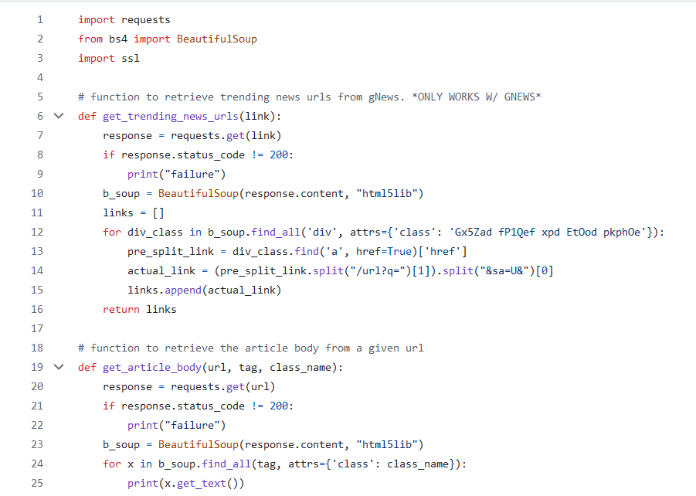

* Headline scraper – to find current trending topics

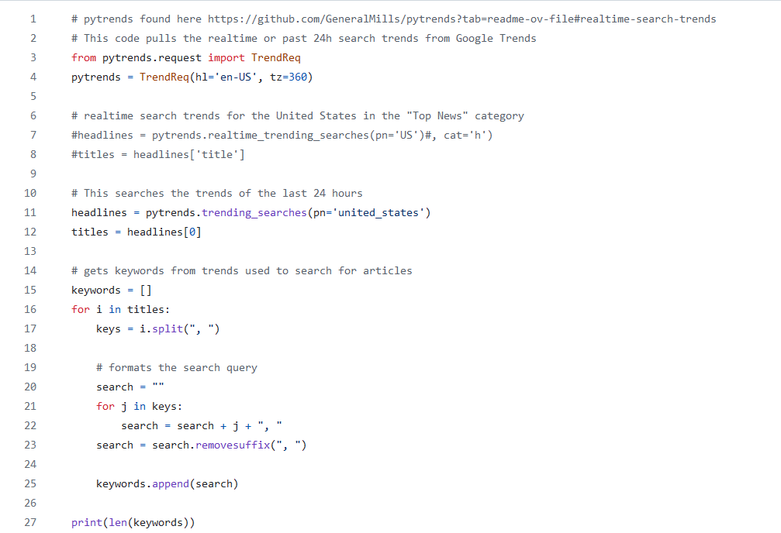

* List of news sources – living document
* Sprint 1: User profiles, use case diagram, product backlog and burndown, etc

Next Week’s Plan:

* Finish and finalize web scraper
* Set up news file storage system
* Begin exploring options for the LLM